**Module 07**

**Forms, Data, and Security**

1. Extend You Application.

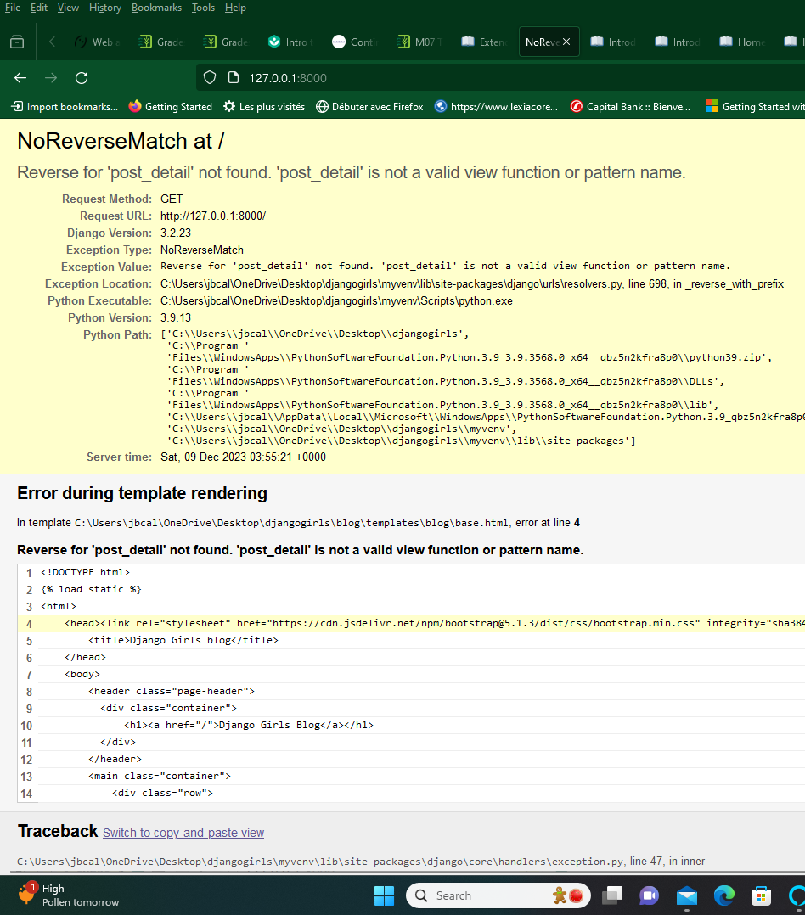

as expected, no URL created yet.

Let's create a URL in urls.py for our post_detail view!

After working on post view, we end up with this:

That happens when you click a link in blog post title.

It is fixed now:

# Django Forms

After pushing to my PythonAnywhere and pulling back, I am still trying to fix some issue.

